**See:** <https://bezkoder.com/node-express-sequelize-postgresql/>

Thanks to: Bezcoder

**Node.js Express & PostgreSQL: CRUD Rest APIs example with Sequelize**

[Last modified: June 30, 2020](https://bezkoder.com/node-express-sequelize-postgresql/)  [bezkoder](https://bezkoder.com/author/bezkoder/)  [Node.js](https://bezkoder.com/category/node-js/)

[Express](https://expressjs.com/) is one of the most popular web frameworks for Node.js that supports routing, middleware, view system… [Sequelize](https://sequelize.org/) is a promise-based Node.js ORM that supports the dialects for PostgreSQL, MySQL, SQL Server… In this tutorial, I will show you step by step to build Node.js Restful CRUD API using Express, Sequelize with PostgreSQL database.

You should install PostgreSQL in your machine first. The installation instructions can be found at [Official PostgreSQL installation manual](https://www.postgresql.org/docs/current/tutorial-install.html).

Fullstack:  
– [Vue.js + Node.js + Express + PostgreSQL example](https://bezkoder.com/vue-node-express-postgresql/)  
– [Angular + Node.js Express + PostgreSQL example](https://bezkoder.com/angular-node-express-postgresql/)  
– [React + Node.js + Express + PostgreSQL example](https://bezkoder.com/react-node-express-postgresql/)

Security: [Node.js Express + Vue.js: JWT Authentication & Authorization example](https://bezkoder.com/node-express-vue-jwt-auth/)

**Contents**[[hide](https://bezkoder.com/node-express-sequelize-postgresql/)]

* [Node.js Rest CRUD API overview](https://bezkoder.com/node-express-sequelize-postgresql/#Nodejs_Rest_CRUD_API_overview)
* [Create Node.js App](https://bezkoder.com/node-express-sequelize-postgresql/#Create_Nodejs_App)
* [Setup Express web server](https://bezkoder.com/node-express-sequelize-postgresql/#Setup_Express_web_server)
* [Configure PostgreSQL database & Sequelize](https://bezkoder.com/node-express-sequelize-postgresql/#Configure_PostgreSQL_database_038_Sequelize)
* [Initialize Sequelize](https://bezkoder.com/node-express-sequelize-postgresql/#Initialize_Sequelize)
* [Define the Sequelize Model](https://bezkoder.com/node-express-sequelize-postgresql/#Define_the_Sequelize_Model)
* [Create the Controller](https://bezkoder.com/node-express-sequelize-postgresql/#Create_the_Controller)
  + [Create a new object](https://bezkoder.com/node-express-sequelize-postgresql/#Create_a_new_object)
  + [Retrieve objects (with condition)](https://bezkoder.com/node-express-sequelize-postgresql/#Retrieve_objects_with_condition)
  + [Retrieve a single object](https://bezkoder.com/node-express-sequelize-postgresql/#Retrieve_a_single_object)
  + [Update an object](https://bezkoder.com/node-express-sequelize-postgresql/#Update_an_object)
  + [Delete an object](https://bezkoder.com/node-express-sequelize-postgresql/#Delete_an_object)
  + [Delete all objects](https://bezkoder.com/node-express-sequelize-postgresql/#Delete_all_objects)
  + [Find all objects by condition](https://bezkoder.com/node-express-sequelize-postgresql/#Find_all_objects_by_condition)
* [Define Routes](https://bezkoder.com/node-express-sequelize-postgresql/#Define_Routes)
* [Test the APIs](https://bezkoder.com/node-express-sequelize-postgresql/#Test_the_APIs)
* [Conclusion](https://bezkoder.com/node-express-sequelize-postgresql/#Conclusion)
* [Further Reading](https://bezkoder.com/node-express-sequelize-postgresql/#Further_Reading)
* [Source code](https://bezkoder.com/node-express-sequelize-postgresql/#Source_code)

**Node.js Rest CRUD API overview**

We will build Rest Apis that can create, retrieve, update, delete and find Tutorials by title.

First, we start with an Express web server. Next, we add configuration for PostgreSQL database, create Tutorial model with Sequelize, write the controller. Then we define routes for handling all CRUD operations (including custom finder).

The following table shows overview of the Rest APIs that will be exported:

| **Methods** | **Urls** | **Actions** |
| --- | --- | --- |
| GET | api/tutorials | get all Tutorials |
| GET | api/tutorials/:id | get Tutorial by id |
| POST | api/tutorials | add new Tutorial |
| PUT | api/tutorials/:id | update Tutorial by id |
| DELETE | api/tutorials/:id | remove Tutorial by id |
| DELETE | api/tutorials | remove all Tutorials |
| GET | api/tutorials/published | find all published Tutorials |
| GET | api/tutorials?title=[kw] | find all Tutorials which title contains 'kw' |

Finally, we’re gonna test the Rest Apis using Postman.

This is our project structure:

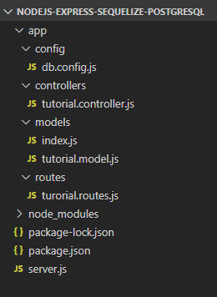

**Create Node.js App**

First, we create a folder:

$ mkdir nodejs-express-sequelize-postgresql

$ cd nodejs-express-sequelize-postgresql

Next, we initialize the Node.js App with a *package.json* file:

npm init

name: (nodejs-express-sequelize-postgresql)

version: (1.0.0)

description: Node.js Rest Apis with Express, Sequelize & PostgreSQL.

entry point: (index.js) server.js

test command:

git repository:

keywords: nodejs, express, sequelize, postgresql, rest, api

author: bezkoder

license: (ISC)

Is this ok? (yes) yes

We need to install necessary modules: express, sequelize, pg, pg-hstore and body-parser.  
Run the command:

npm install express sequelize pg pg-hstore body-parser cors --save

*pg for PostgreSQL and pg-hstore for converting data into the PostgreSQL hstore format.

The *package.json* file should look like this:

{

"name": "nodejs-express-sequelize-postgresql",

"version": "1.0.0",

"description": "Node.js Rest Apis with Express, Sequelize & M",

"main": "server.js",

"scripts": {

"test": "echo \"Error: no test specified\" && exit 1"

},

"keywords": [

"nodejs",

"express",

"sequelize",

"rest",

"api",

"postgresql"

],

"author": "bezkoder",

"license": "ISC",

"dependencies": {

"body-parser": "^1.19.0",

"cors": "^2.8.5",

"express": "^4.17.1",

"pg": "^7.17.1",

"pg-hstore": "^2.3.3",

"sequelize": "^5.21.3"

}

}

**Setup Express web server**

In the root folder, let’s create a new *server.js* file:

const express = require("express");

const bodyParser = require("body-parser");

const cors = require("cors");

const app = express();

var corsOptions = {

origin: "http://localhost:8081"

};

app.use(cors(corsOptions));

// parse requests of content-type - application/json

app.use(bodyParser.json());

// parse requests of content-type - application/x-www-form-urlencoded

app.use(bodyParser.urlencoded({ extended: true }));

// simple route

app.get("/", (req, res) => {

res.json({ message: "Welcome to bezkoder application." });

});

// set port, listen for requests

const PORT = process.env.PORT || 8080;

app.listen(PORT, () => {

console.log(`Server is running on port ${PORT}.`);

});

What we do are:  
– import express, body-parser and cors modules:

* Express is for building the Rest apis
* [body-parser](https://www.npmjs.com/package/body-parser) helps to parse the request and create the req.body object
* [cors](https://www.npmjs.com/package/cors) provides Express middleware to enable CORS with various options.

– create an Express app, then add body-parser and cors middlewares using app.use() method. Notice that we set origin: http://localhost:8081.  
– define a GET route which is simple for test.  
– listen on port 8080 for incoming requests.

Now let’s run the app with command: node server.js.  
Open your browser with url <http://localhost:8080/>, you will see:

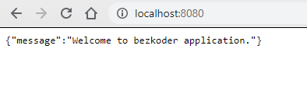

Yeah, the first step is done. We’re gonna work with Sequelize in the next section.

**Configure PostgreSQL database & Sequelize**

In the *app* folder, we create a separate *config* folder for configuration with *db.config.js* file like this:

module.exports = {

HOST: "localhost",

USER: "postgres",

PASSWORD: "123",

DB: "testdb",

dialect: "postgres",

pool: {

max: 5,

min: 0,

acquire: 30000,

idle: 10000

}

};

First five parameters are for PostgreSQL connection.  
pool is optional, it will be used for Sequelize connection pool configuration:

* max: maximum number of connection in pool
* min: minimum number of connection in pool
* idle: maximum time, in milliseconds, that a connection can be idle before being released
* acquire: maximum time, in milliseconds, that pool will try to get connection before throwing error

For more details, please visit [API Reference for the Sequelize constructor](https://sequelize.org/master/class/lib/sequelize.js~Sequelize.html#instance-constructor-constructor).

**Initialize Sequelize**

We’re gonna initialize Sequelize in **app**/**models** folder that will contain model in the next step.

Now create **app**/**models**/*index.js* with the following code:

const dbConfig = require("../config/db.config.js");

const Sequelize = require("sequelize");

const sequelize = new Sequelize(dbConfig.DB, dbConfig.USER, dbConfig.PASSWORD, {

host: dbConfig.HOST,

dialect: dbConfig.dialect,

operatorsAliases: false,

pool: {

max: dbConfig.pool.max,

min: dbConfig.pool.min,

acquire: dbConfig.pool.acquire,

idle: dbConfig.pool.idle

}

});

const db = {};

db.Sequelize = Sequelize;

db.sequelize = sequelize;

db.tutorials = require("./tutorial.model.js")(sequelize, Sequelize);

module.exports = db;

Don’t forget to call sync() method in *server.js*:

...

const app = express();

app.use(...);

const db = require("./app/models");

db.sequelize.sync();

...

In development, you may need to drop existing tables and re-sync database. Just use force: true as following code:

db.sequelize.sync({ force: true }).then(() => {

console.log("Drop and re-sync db.");

});

**Define the Sequelize Model**

In *models* folder, create *tutorial.model.js* file like this:

module.exports = (sequelize, Sequelize) => {

const Tutorial = sequelize.define("tutorial", {

title: {

type: Sequelize.STRING

},

description: {

type: Sequelize.STRING

},

published: {

type: Sequelize.BOOLEAN

}

});

return Tutorial;

};

This Sequelize Model represents **tutorials** table in PostgreSQL database. These columns will be generated automatically: *id*, *title*, *description*, *published*, *createdAt*, *updatedAt*.

After initializing Sequelize, we don’t need to write CRUD functions, Sequelize supports all of them:

* create a new Tutorial: [create](https://sequelize.org/master/class/lib/model.js~Model.html#static-method-create)(object)
* find a Tutorial by id: [findByPk](https://sequelize.org/master/class/lib/model.js~Model.html" \l "static-method-findByPk)(id)
* get all Tutorials: [findAll](https://sequelize.org/master/class/lib/model.js~Model.html" \l "static-method-findAll)()
* update a Tutorial by id: [update](https://sequelize.org/master/class/lib/model.js~Model.html#static-method-update)(data, where: { id: id })
* remove a Tutorial: [destroy](https://sequelize.org/master/class/lib/model.js~Model.html#static-method-destroy)(where: { id: id })
* remove all Tutorials: destroy(where: {})
* find all Tutorials by title: findAll({ where: { title: ... } })

These functions will be used in our Controller.

We can improve the example by adding Comments for each Tutorial. It is the One-to-Many Relationship and I write a tutorial for this at:  
[Node.js Sequelize Associations: One-to-Many example](https://bezkoder.com/sequelize-associate-one-to-many/)

Or you can add Tags for each Tutorial and add Tutorials to Tag (Many-to-Many Relationship):  
[Node.js Sequelize Associations: Many-to-Many example](https://bezkoder.com/sequelize-associate-many-to-many/)

**Create the Controller**

Inside **app**/**controllers** folder, let’s create *tutorial.controller.js* with these CRUD functions:

* create
* findAll
* findOne
* update
* delete
* deleteAll
* findAllPublished

const db = require("../models");

const Tutorial = db.tutorials;

const Op = db.Sequelize.Op;

// Create and Save a new Tutorial

exports.create = (req, res) => {

};

// Retrieve all Tutorials from the database.

exports.findAll = (req, res) => {

};

// Find a single Tutorial with an id

exports.findOne = (req, res) => {

};

// Update a Tutorial by the id in the request

exports.update = (req, res) => {

};

// Delete a Tutorial with the specified id in the request

exports.delete = (req, res) => {

};

// Delete all Tutorials from the database.

exports.deleteAll = (req, res) => {

};

// Find all published Tutorials

exports.findAllPublished = (req, res) => {

};

Let’s implement these functions.

**Create a new object**

Create and Save a new Tutorial:

exports.create = (req, res) => {

// Validate request

if (!req.body.title) {

res.status(400).send({

message: "Content can not be empty!"

});

return;

}

// Create a Tutorial

const tutorial = {

title: req.body.title,

description: req.body.description,

published: req.body.published ? req.body.published : false

};

// Save Tutorial in the database

Tutorial.create(tutorial)

.then(data => {

res.send(data);

})

.catch(err => {

res.status(500).send({

message:

err.message || "Some error occurred while creating the Tutorial."

});

});

};

**Retrieve objects (with condition)**

Retrieve all Tutorials/ find by title from the database:

exports.findAll = (req, res) => {

const title = req.query.title;

var condition = title ? { title: { [Op.iLike]: `%${title}%` } } : null;

Tutorial.findAll({ where: condition })

.then(data => {

res.send(data);

})

.catch(err => {

res.status(500).send({

message:

err.message || "Some error occurred while retrieving tutorials."

});

});

};

We use req.query.title to get query string from the Request and consider it as condition for findAll() method.

**Retrieve a single object**

Find a single Tutorial with an id:

exports.findOne = (req, res) => {

const id = req.params.id;

Tutorial.findByPk(id)

.then(data => {

res.send(data);

})

.catch(err => {

res.status(500).send({

message: "Error retrieving Tutorial with id=" + id

});

});

};

**Update an object**

Update a Tutorial identified by the id in the request:

exports.update = (req, res) => {

const id = req.params.id;

Tutorial.update(req.body, {

where: { id: id }

})

.then(num => {

if (num == 1) {

res.send({

message: "Tutorial was updated successfully."

});

} else {

res.send({

message: `Cannot update Tutorial with id=${id}. Maybe Tutorial was not found or req.body is empty!`

});

}

})

.catch(err => {

res.status(500).send({

message: "Error updating Tutorial with id=" + id

});

});

};

**Delete an object**

Delete a Tutorial with the specified id:

exports.delete = (req, res) => {

const id = req.params.id;

Tutorial.destroy({

where: { id: id }

})

.then(num => {

if (num == 1) {

res.send({

message: "Tutorial was deleted successfully!"

});

} else {

res.send({

message: `Cannot delete Tutorial with id=${id}. Maybe Tutorial was not found!`

});

}

})

.catch(err => {

res.status(500).send({

message: "Could not delete Tutorial with id=" + id

});

});

};

**Delete all objects**

Delete all Tutorials from the database:

exports.deleteAll = (req, res) => {

Tutorial.destroy({

where: {},

truncate: false

})

.then(nums => {

res.send({ message: `${nums} Tutorials were deleted successfully!` });

})

.catch(err => {

res.status(500).send({

message:

err.message || "Some error occurred while removing all tutorials."

});

});

};

**Find all objects by condition**

Find all Tutorials with published = true:

exports.findAllPublished = (req, res) => {

Tutorial.findAll({ where: { published: true } })

.then(data => {

res.send(data);

})

.catch(err => {

res.status(500).send({

message:

err.message || "Some error occurred while retrieving tutorials."

});

});

};

**Define Routes**

When a client sends request for an endpoint using HTTP request (GET, POST, PUT, DELETE), we need to determine how the server will reponse by setting up the routes.

These are our routes:

* /api/tutorials: GET, POST, DELETE
* /api/tutorials/:id: GET, PUT, DELETE
* /api/tutorials/published: GET

Create a *turorial.routes.js* inside *app/routes* folder with content like this:

module.exports = app => {

const tutorials = require("../controllers/tutorial.controller.js");

var router = require("express").Router();

// Create a new Tutorial

router.post("/", tutorials.create);

// Retrieve all Tutorials

router.get("/", tutorials.findAll);

// Retrieve all published Tutorials

router.get("/published", tutorials.findAllPublished);

// Retrieve a single Tutorial with id

router.get("/:id", tutorials.findOne);

// Update a Tutorial with id

router.put("/:id", tutorials.update);

// Delete a Tutorial with id

router.delete("/:id", tutorials.delete);

// Create a new Tutorial

router.delete("/", tutorials.deleteAll);

app.use('/api/tutorials', router);

};

You can see that we use a controller from /controllers/tutorial.controller.js.

We also need to include routes in *server.js* (right before app.listen()):

...

require("./app/routes/turorial.routes")(app);

// set port, listen for requests

const PORT = ...;

app.listen(...);

**Test the APIs**

Run our Node.js application with command: node server.js.

Using Postman, we’re gonna test all the Apis above.

1. **Create a new Tutorial using POST /tutorials Api**

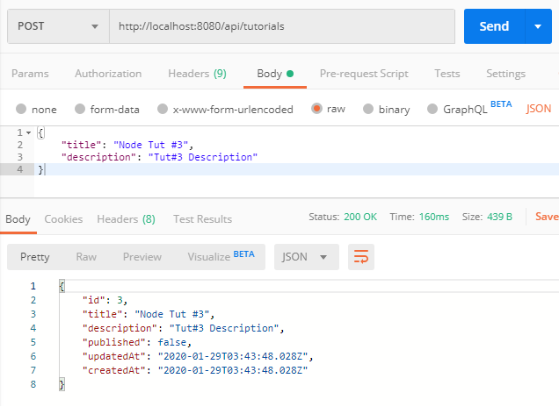

After creating some new Tutorials, you can check PostgreSQL table:

testdb=# select * from tutorials;

id | title | description | published | createdAt | updatedAt

----+-------------+-------------------+-----------+----------------------------+----------------------------

1 | Node Tut #1 | Tut#1 Description | f | 2020-01-29 10:42:57.121+07 | 2020-01-29 10:42:57.121+07

2 | Node Tut #2 | Tut#2 Description | f | 2020-01-29 10:43:05.131+07 | 2020-01-29 10:43:05.131+07

3 | Node Tut #3 | Tut#3 Description | f | 2020-01-29 10:43:48.028+07 | 2020-01-29 10:43:48.028+07

4 | Js Tut #4 | Tut#4 Desc | f | 2020-01-29 10:45:40.016+07 | 2020-01-29 10:45:40.016+07

5 | Js Tut #5 | Tut#5 Desc | f | 2020-01-29 10:45:44.289+07 | 2020-01-29 10:45:44.289+07

1. **Retrieve all Tutorials using GET /tutorials Api**

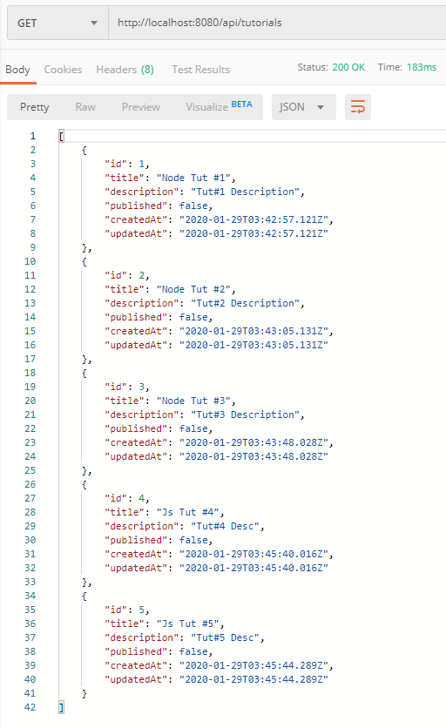

1. **Retrieve a single Tutorial by id using GET /tutorials/:id Api**

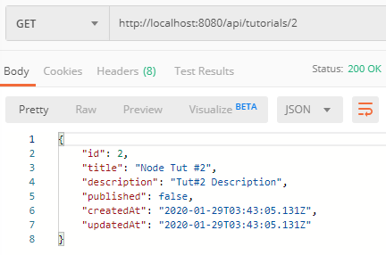

1. **Update a Tutorial using PUT /tutorials/:id Api**

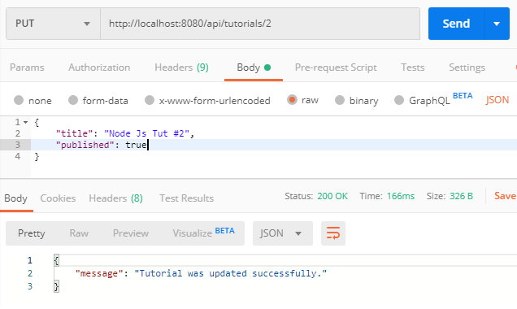

Check tutorials table after some rows were updated:

testdb=# select * from tutorials;

id | title | description | published | createdAt | updatedAt

----+----------------+-------------------+-----------+----------------------------+----------------------------

1 | Node Tut #1 | Tut#1 Description | f | 2020-01-29 10:42:57.121+07 | 2020-01-29 10:42:57.121+07

3 | Node Tut #3 | Tut#3 Description | f | 2020-01-29 10:43:48.028+07 | 2020-01-29 10:43:48.028+07

2 | Node Js Tut #2 | Tut#2 Description | t | 2020-01-29 10:43:05.131+07 | 2020-01-29 10:51:55.235+07

4 | Js Tut #4 | Tut#4 Desc | t | 2020-01-29 10:45:40.016+07 | 2020-01-29 10:54:17.468+07

5 | Js Tut #5 | Tut#5 Desc | t | 2020-01-29 10:45:44.289+07 | 2020-01-29 10:54:20.544+07

1. **Find all Tutorials which title contains ‘js’: GET /tutorials?title=js**

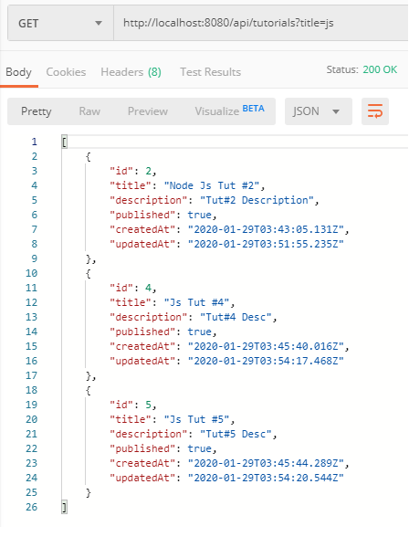

1. **Find all published Tutorials using GET /tutorials/published Api**

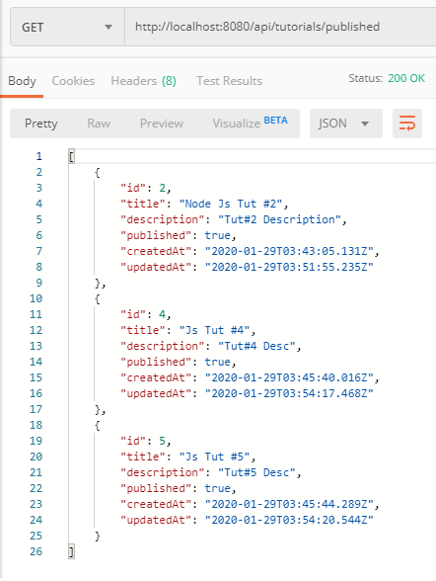

1. **Delete a Tutorial using DELETE /tutorials/:id Api**

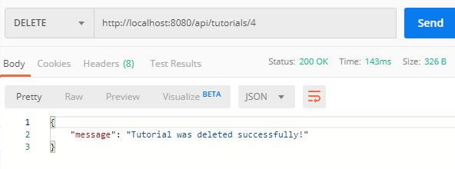

Tutorial with id=4 was removed from tutorials table:

testdb=# select * from tutorials;

id | title | description | published | createdAt | updatedAt

----+----------------+-------------------+-----------+----------------------------+----------------------------

1 | Node Tut #1 | Tut#1 Description | f | 2020-01-29 10:42:57.121+07 | 2020-01-29 10:42:57.121+07

3 | Node Tut #3 | Tut#3 Description | f | 2020-01-29 10:43:48.028+07 | 2020-01-29 10:43:48.028+07

2 | Node Js Tut #2 | Tut#2 Description | t | 2020-01-29 10:43:05.131+07 | 2020-01-29 10:51:55.235+07

5 | Js Tut #5 | Tut#5 Desc | t | 2020-01-29 10:45:44.289+07 | 2020-01-29 10:54:20.544+07

1. **Delete all Tutorials using DELETE /tutorials Api**

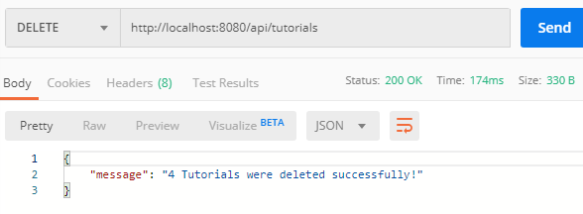

Now there are no rows in tutorials table:

testdb=# select * from tutorials;

id | title | description | published | createdAt | updatedAt

----+-------+-------------+-----------+-----------+-----------

**Conclusion**

Today, we’ve learned how to create Node.js Rest Apis with an Express web server to interact with PostgreSQL database. We also know way to add configuration for PostgreSQL database & Sequelize, create a Sequelize Model, write a controller and define routes for handling all CRUD operations.

You can also find how to build a fullstack system with this app as backend server in the posts:  
– [Vue.js + Node.js Express + PostgreSQL example: Build a CRUD App](https://bezkoder.com/vue-node-express-postgresql/)  
– [Angular + Node.js Express + PostgreSQL example: Build a CRUD App](https://bezkoder.com/angular-node-express-postgresql/)  
– [React + Node.js Express + PostgreSQL example: Build a CRUD App](https://bezkoder.com/react-node-express-postgresql/)

Happy learning! See you again.

**Further Reading**

* [Express.js Routing](http://expressjs.com/en/guide/routing.html)
* <https://www.npmjs.com/package/express>
* <https://www.npmjs.com/package/body-parser>
* <https://www.npmjs.com/package/pg>
* [Tutorials and Guides for Sequelize v5](https://sequelize.org/master/)

**Source code**

You can find the complete source code for this example on [Github](https://github.com/bezkoder/node-express-sequelize-postgresql).

If you want to add Comments for each Tutorial. It is the One-to-Many Relationship there is a tutorial:  
[Node.js Sequelize Associations: One-to-Many example](https://bezkoder.com/sequelize-associate-one-to-many/)  
(the tutorial uses MySQL but you can easily change the configuration for PostgreSQL)

Or you can add Tags for each Tutorial and add Tutorials to Tag (Many-to-Many Relationship):  
[Node.js Sequelize Associations: Many-to-Many example](https://bezkoder.com/sequelize-associate-many-to-many/)